AIZA NIZAM 25F-CY-103

Lab#11
Objective:
To understand the file management in windows

Abstract:
We are going to understand the basic process of organizing and handling files and folders in a computer system. Efficient
file management improves productivity and helps prevent data loss.

Procedure:
1. Open File Explorer.
2. Navigate to the desired location (e.g., Desktop or Documents).
3. Right-click → New → Folder → Name it LabFiles.
4. Inside the folder, create new text files:
Assignment:

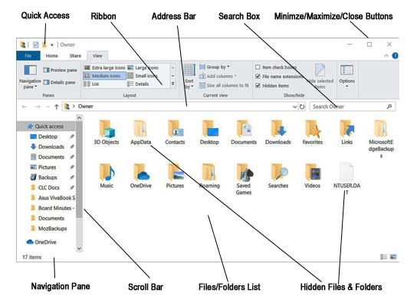

Conclusion:

We Have learned basic file and folder operations in Windows.

